DBMS Assignment Lab 8

Tarun M

PES1UG20CS462

1)

DELIMITER $$

CREATE FUNCTION no_of_tckts(P_ID varchar(255))

RETURNS varchar(255)

DETERMINISTIC

BEGIN

DECLARE out varchar(255);

DECLARE tickets int;

SELECT count(pnr) into tickets

FROM ticket

WHERE passenger_id = P_ID AND MONTH(travel_date) = MONTH(NOW()) AND

YEAR(travel_date) = YEAR(NOW());

IF tickets > 3 THEN

SET out = 'cannot purchase tickets current limit is over”';

ELSE

SET out = 'can purchase tickets';

END IF;

RETURN out;

END; $$

DELIMITER ;

SELECT number_of_tickets('ADM_001') from ticket;

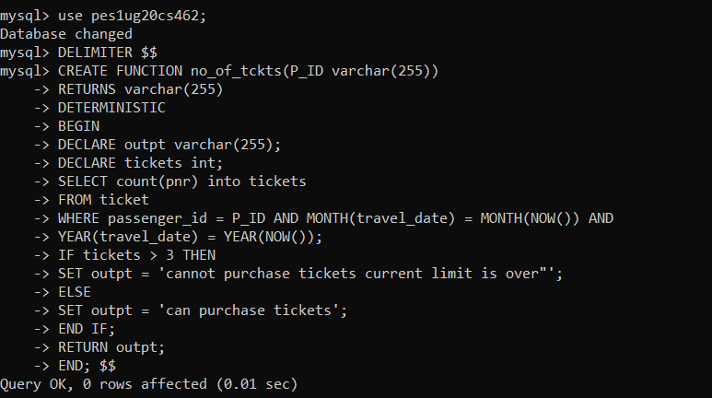

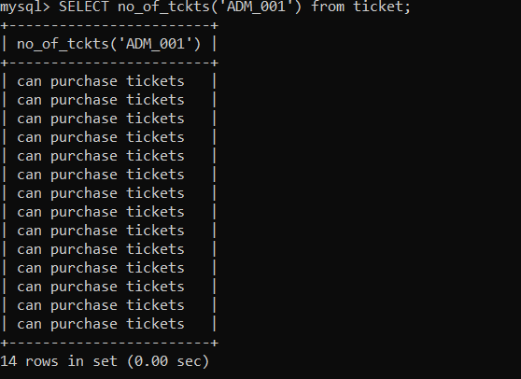

2)

DELIMITER $$  
CREATE procedure upd_age(IN U_ID varchar(30), IN DOB DATE)  
BEGIN  
DECLARE age_new int;  
SET age_new = FLOOR(DATEDIFF(NOW(),DOB)/365);  
UPDATE train_user set age = age_new where user_id = U_ID;  
END;$$  
DELIMITER ;  
CALL upd_age('ADM_001','1989-04-14');

SELECT * FROM train_user WHERE user_id='ADM_001';

